Great Jasmine

1. Honestly, I thought you were going to use a new concept for the websites. NCIC and Great Jasmine still look like the old websites with a little change.
2. Also, I am not sure why you made changes to the existing sites for NCIC and Great Jasmine. We are still using them and some of the pages are no longer working. Please check and rectify. Thanks

Home page

1. Can you make the logo of Great Jasmine bigger on the home page?
2. The slider. You wrote Caregiver, you put the photo of a governess and the write-up of a governess
3. There is no slider for Governess
4. Change the photo of the Safety Service on the home slider to what you used for NCIC
5. The testimonials should scroll across the page. I don’t like how it is on the website. You can put the Safety tips under or above it and not beside it. Please see how it is on the current website and apply. Thanks
6. On the whole website, the sequence should be: Executive/Personal Assistant, Governess (remove the services beside governess), Caregivers, CCTV Installation, Fire Safety

Services

1. Kindly change the photo for Caregiver on the Caregiver page. I gave you some photos to use
2. Also change the photo of the Governess on the governess page. Don’t use the ones with write-up

Request a Service

1. On the “Request a Service page, the email that the request should go to is [contact@greatjasmine.com.ng](mailto:contact@greatjasmine.com.ng)
2. The captcha is not showing

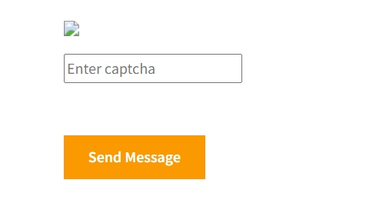

1. The “Find a sitter now” link should still remain on the request a service page and not the Get in Touch page
2. The home link at the bottom still takes you back to request a service page and not the home page. These are not the type of corrections we should be talking about. You should test the links you put to make sure they get to the right page.

Jobs

1. The photo on jobs is not properly aligned. It should come down a bit so the write-up shows. Jobs is cut off from the top

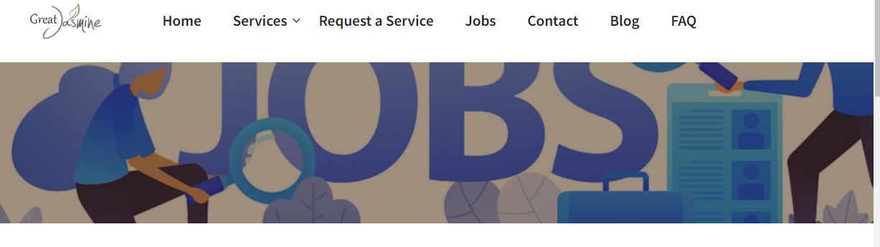

1. The write up starting with As a dedicated Caregiver or Governess… needs spaces, paragraphs, etc so it is easy to read.
2. I don’t see the need for the rows below asking for Name, phone, email, Just the Apply for this job link is ok. When they click on it, a page asking for name, phone, email and ability to upload resume should pop up. Also include the position so they can write cost accountant, Governess, Caregiver etc. This way all application links will come here.

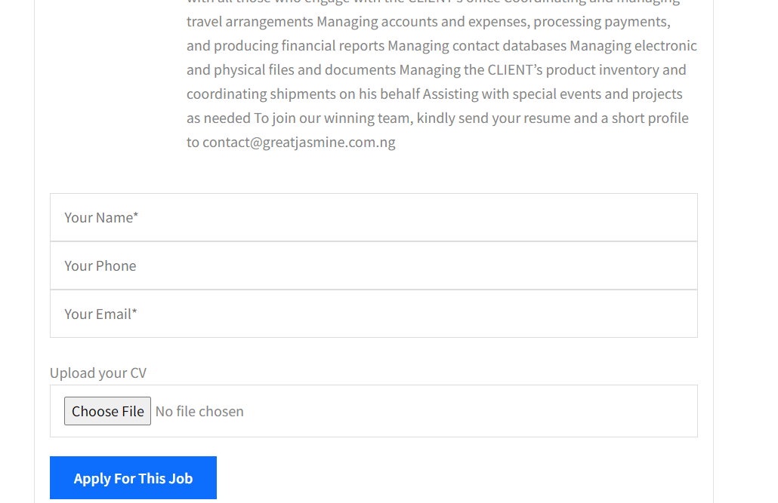

1. Using the sample jobs you posted, eg Management Accountant, when you click on Apply for this job, it takes you back to the same page. Let the apply for this job take you to the link created for 17. This way all job applicants are taken to the same link. They will now signify the position they are applying for in the row you will provide. Eg, looking at 17, it will look like this:

Name\*

Phone number\*

Email\*

Position\*

Upload your Resume

Blog

1. The home page at the bottom also goes to the wrong page
2. Kindly remove the LinkedIn link. GJ does not have a LinkedIn page.
3. Please the Instagram is not connecting well
4. The Instagram link on top takes you back to the blog page. Kindly test all your links as stated above to ensure they go were they are supposed to.
5. The Great Jasmine Logo at the bottom is not clear. Since you wish to use a charcoal colour, then make the Great Pop.